**JUST CALL UZ**

Jobs Module Date:10/01/2013

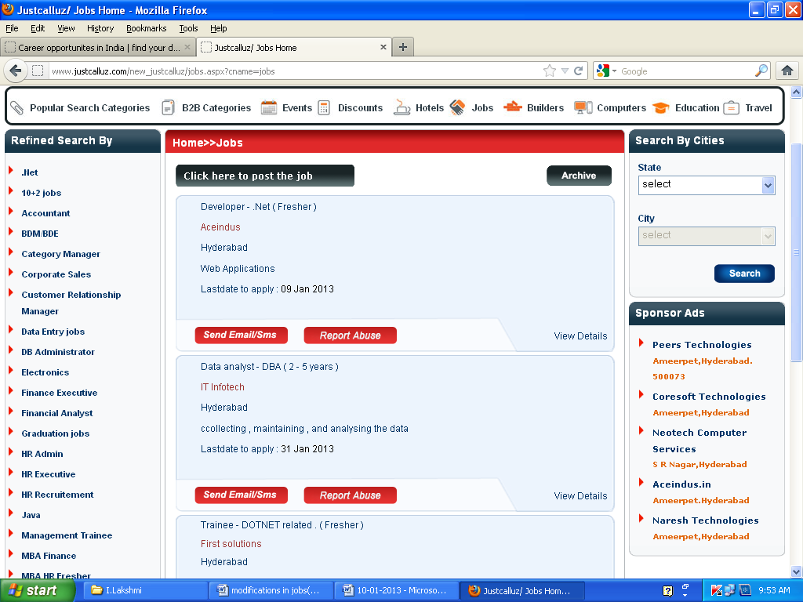

Still it displays in jobs list eventhough the date was expired.It is not moving to Archive.

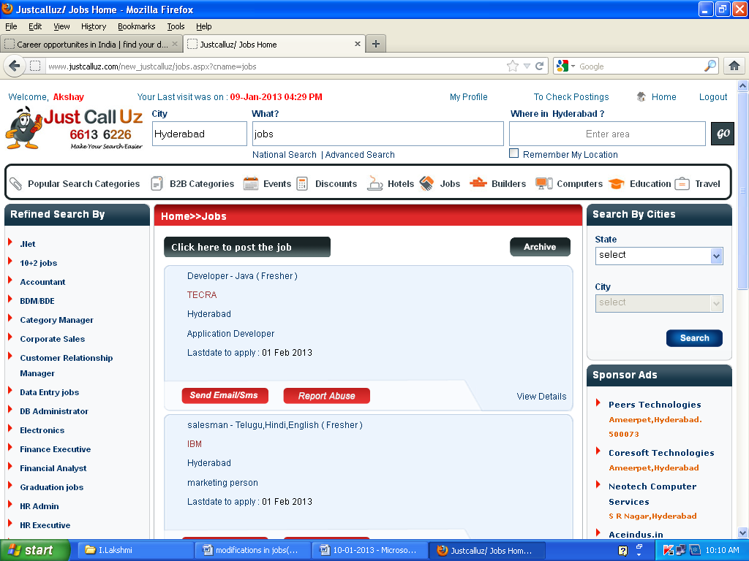 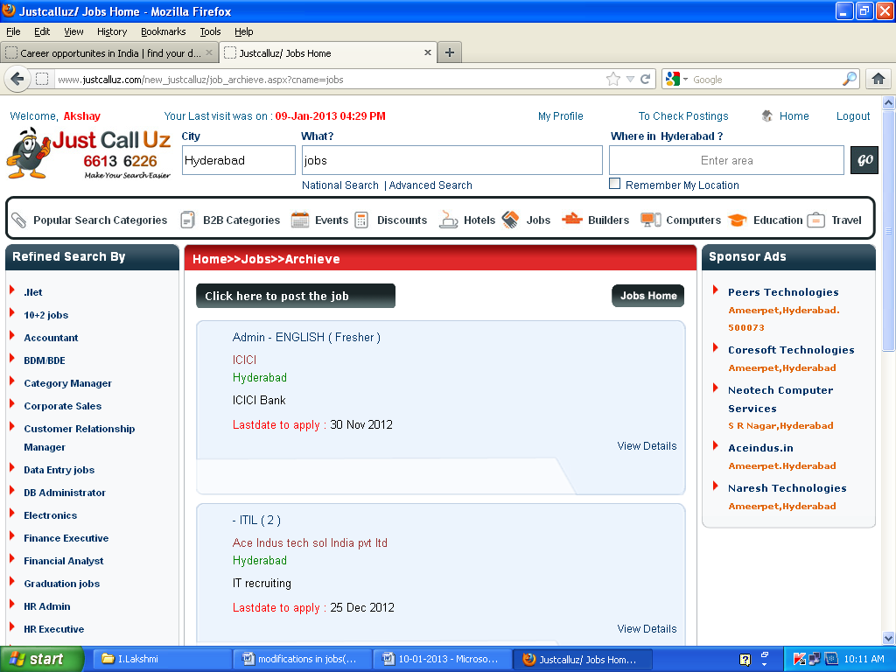

Archive spelling is different

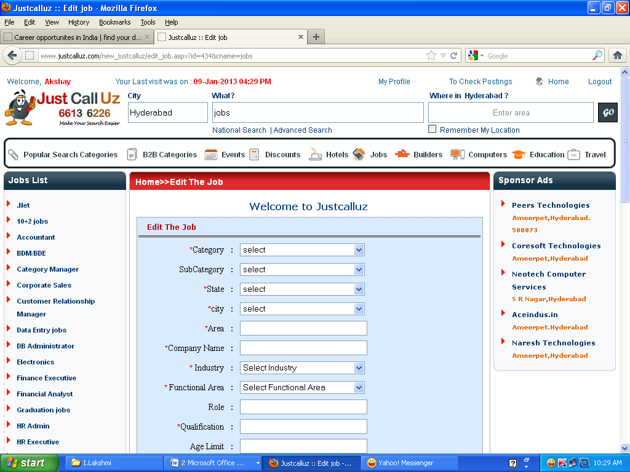

* After Editing , it is returning to same page. It will be good if it returns to previous page.

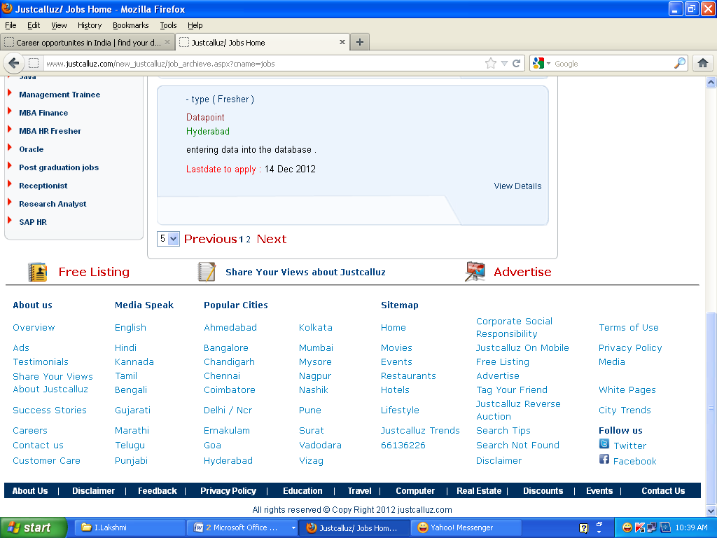

* Hide the dropdownlist.

Life Style Module

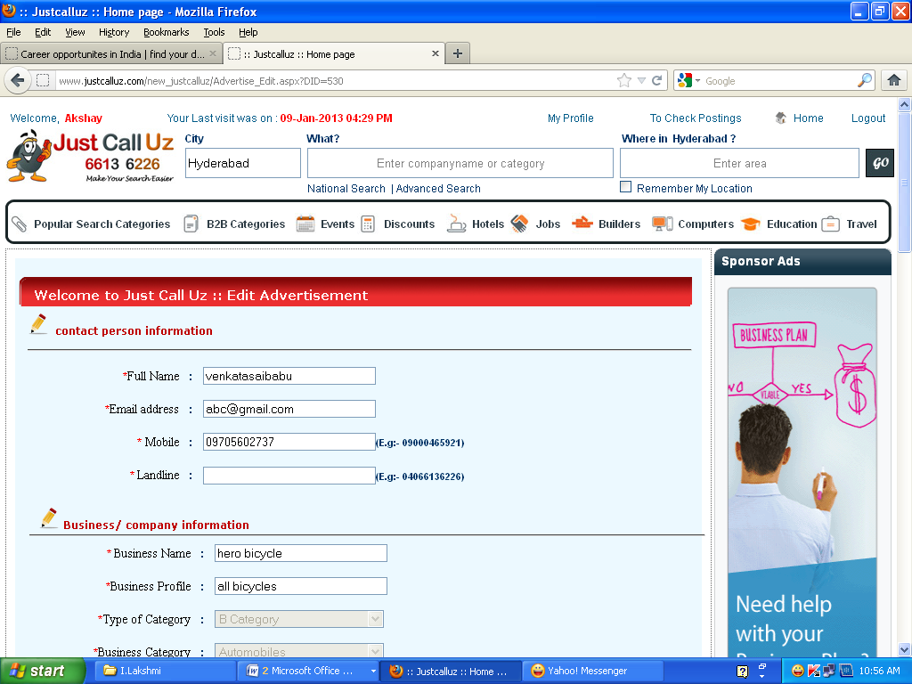

* Landline, LandMark,Fax has no validations. Remove the red colour stars.

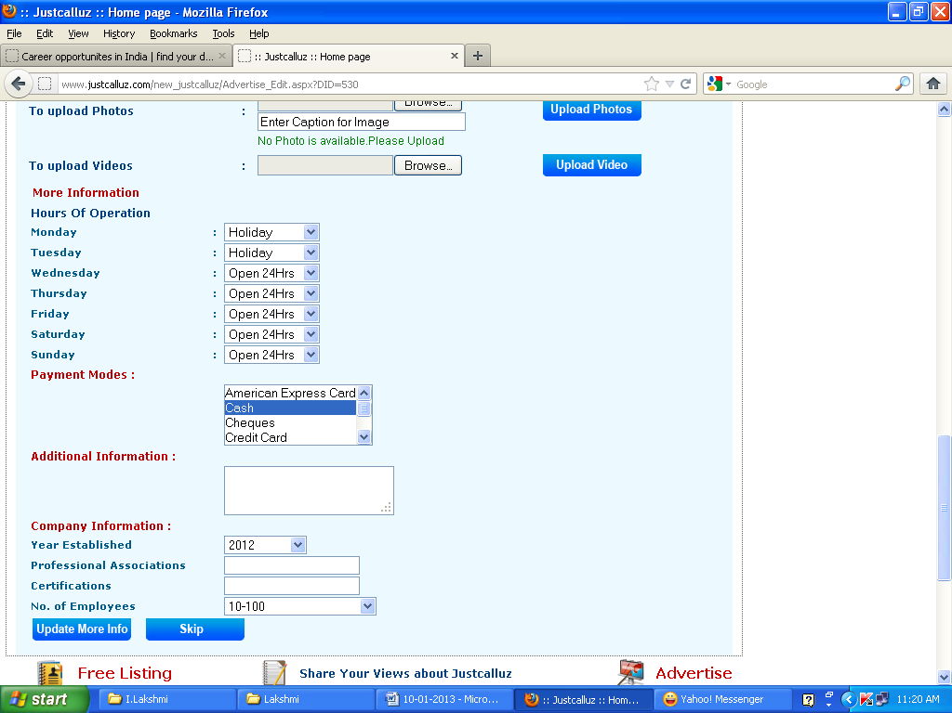

* After clicking Update More Info, it is returning to same page. It will be better if it returns to previous page.

Pending:

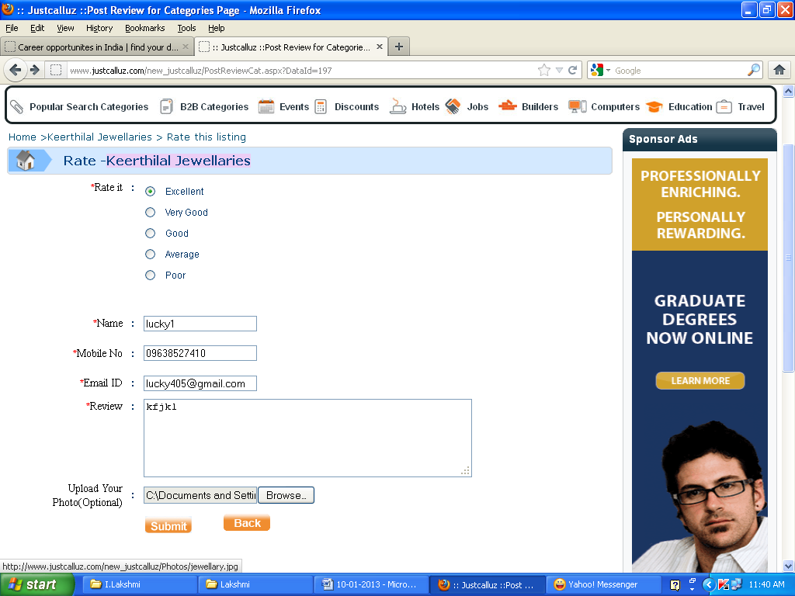

* After clicking submit button ,it displays empty space in the place of image see the next printscreen

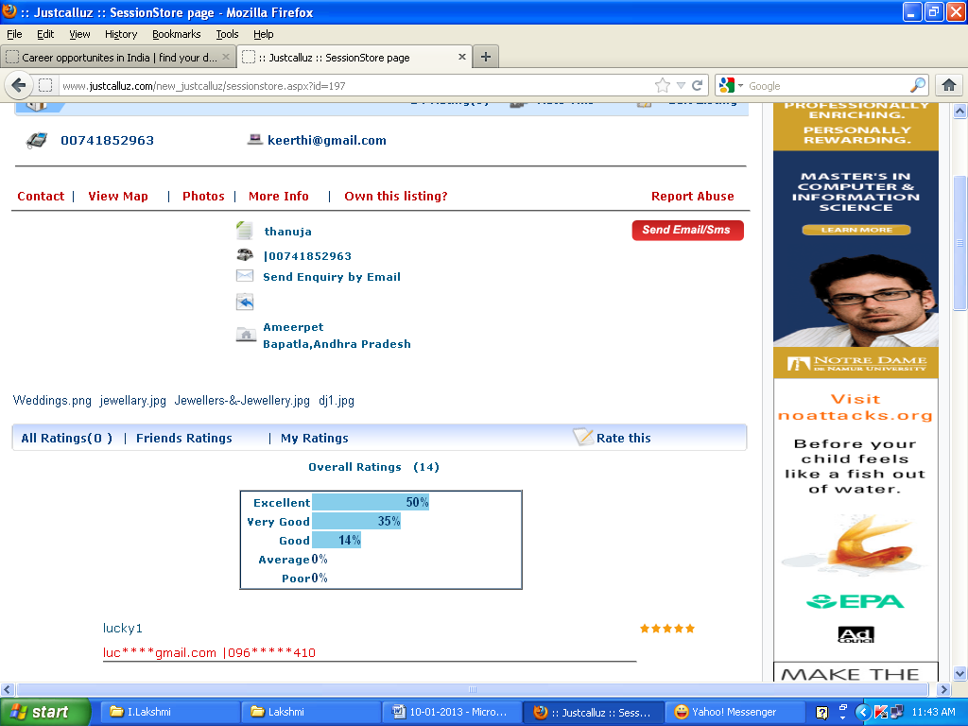

photo

Image

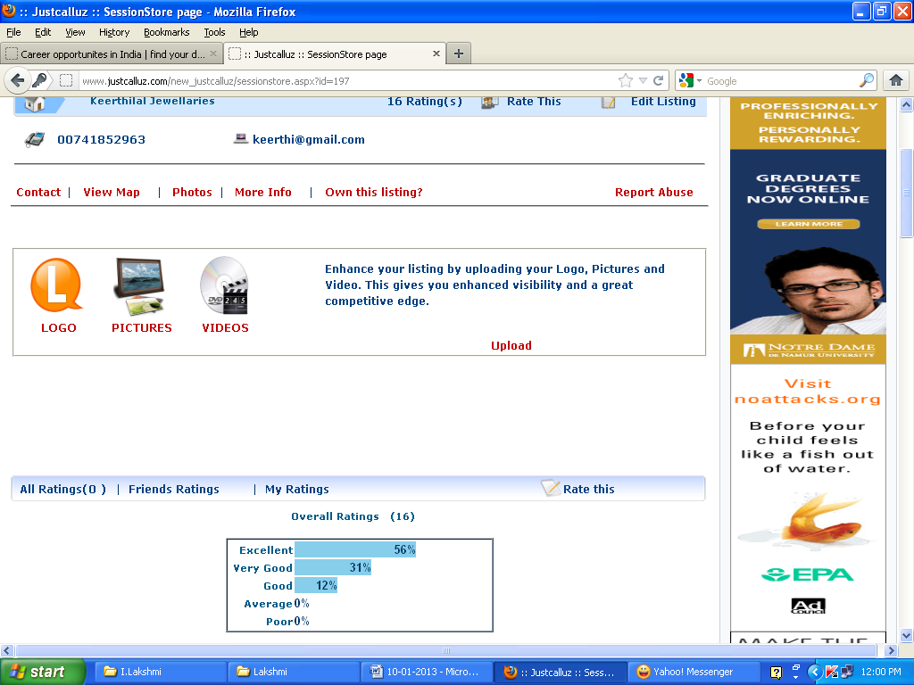

When I clicked on Own this listing and upload then it is getting unnecessary popup boxes down in the page see the next printscreen

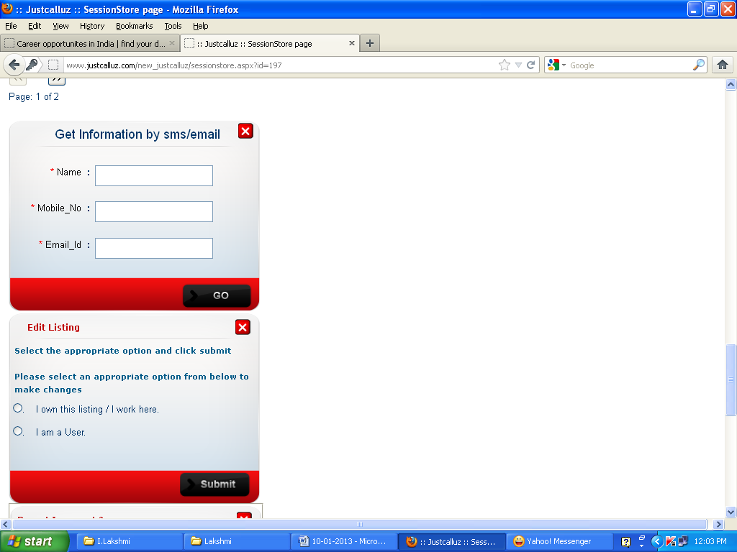

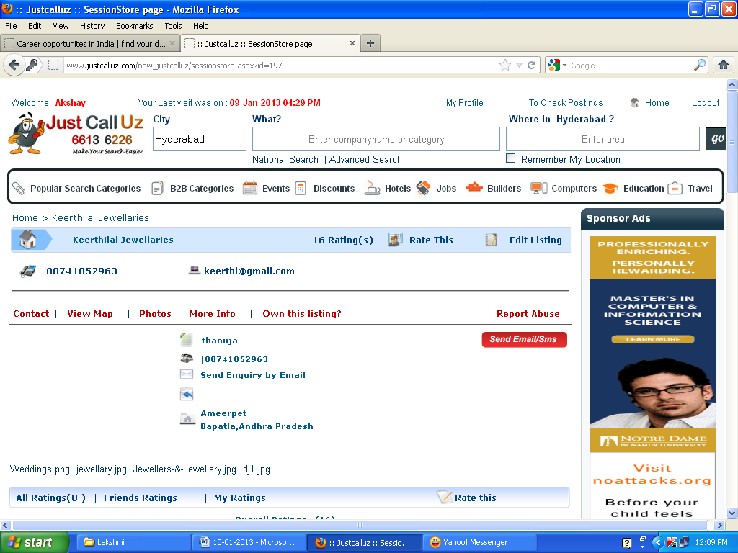

**Back**

* My **SUGGESTION** is need back button here to go the lifestyle page.

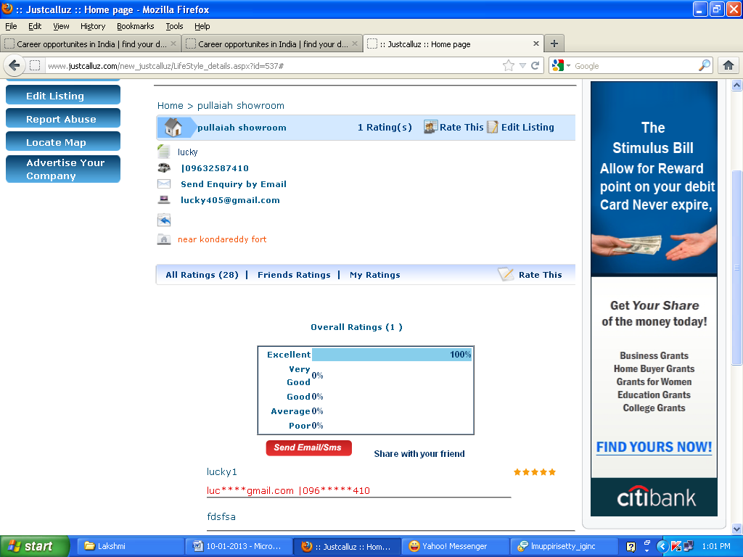

Link Buttons (All ratings, friends ratings, my ratings) are not working

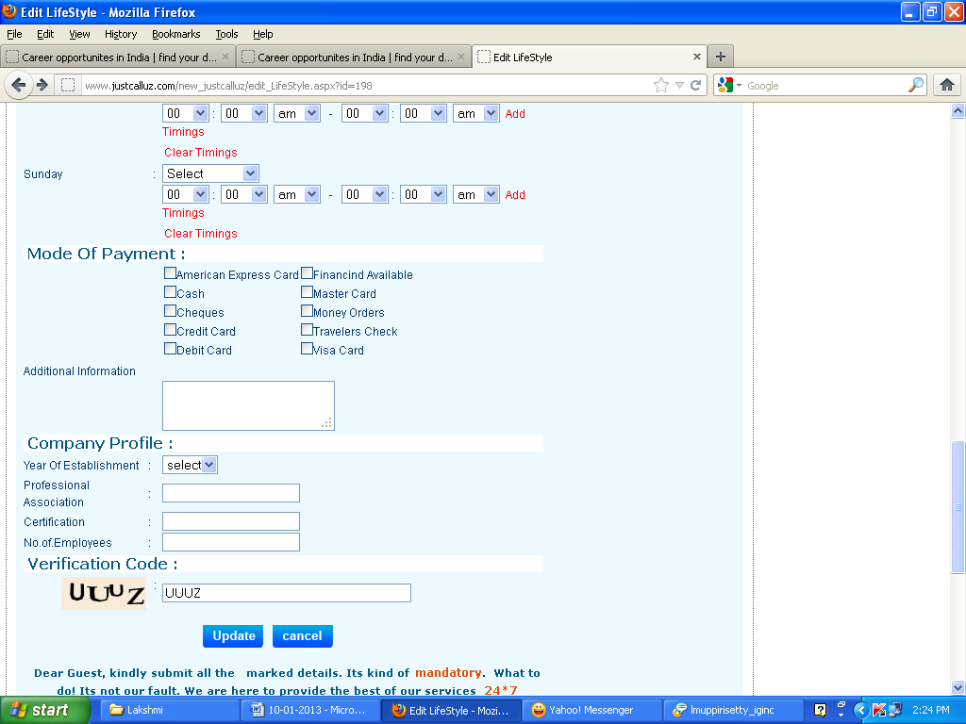

* Got an error message when I clicked on Update Button in life style module.See the next print screen

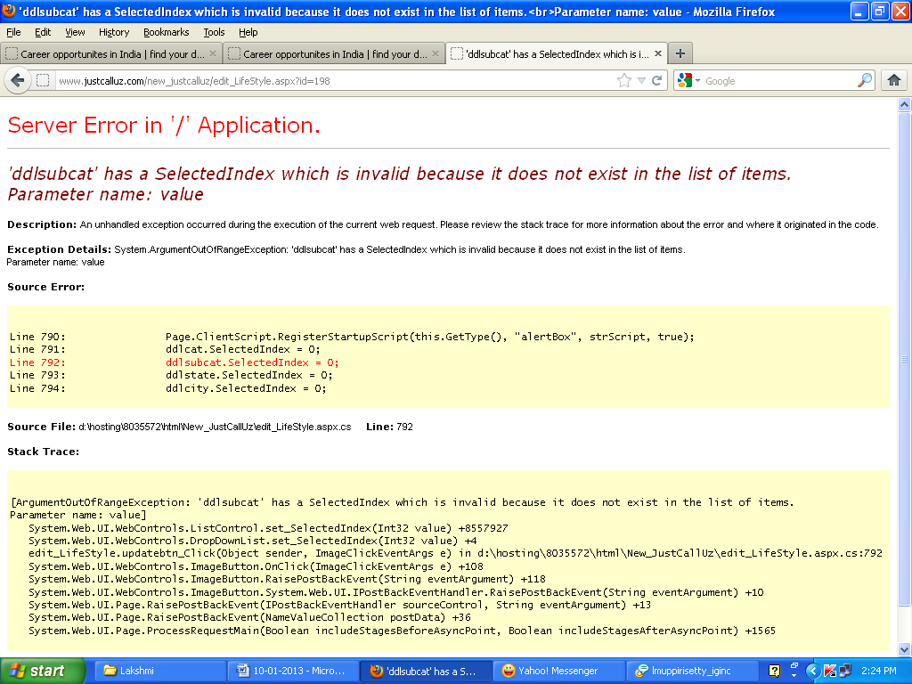

Events Module

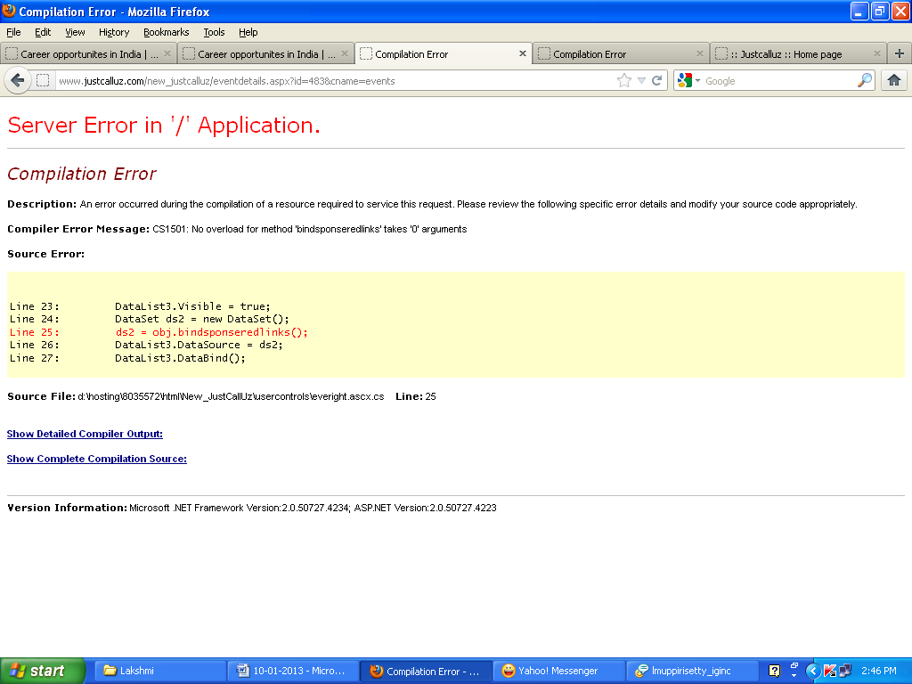

* Got an error when I Clicked on view details in the Events.

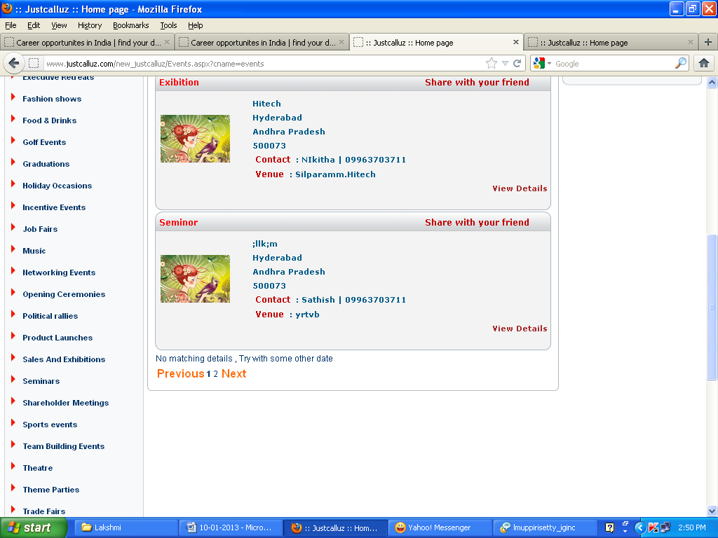

* When I choose false date in the events module it is displaying both the events and also message i.e.,No matching details

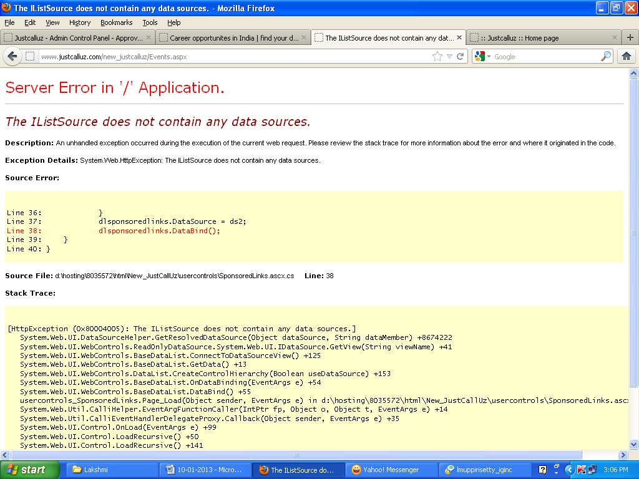

* Got an error after submitting the **Go** Button in **Share With Your Friend** option in the **EVENTS** module

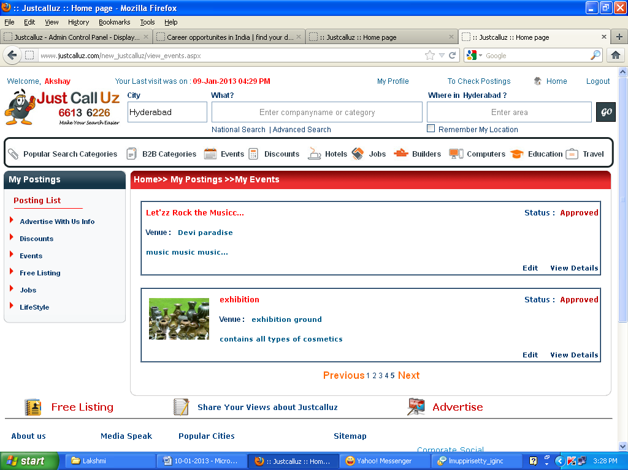

* Recent post data is displaying last in the **Events** list

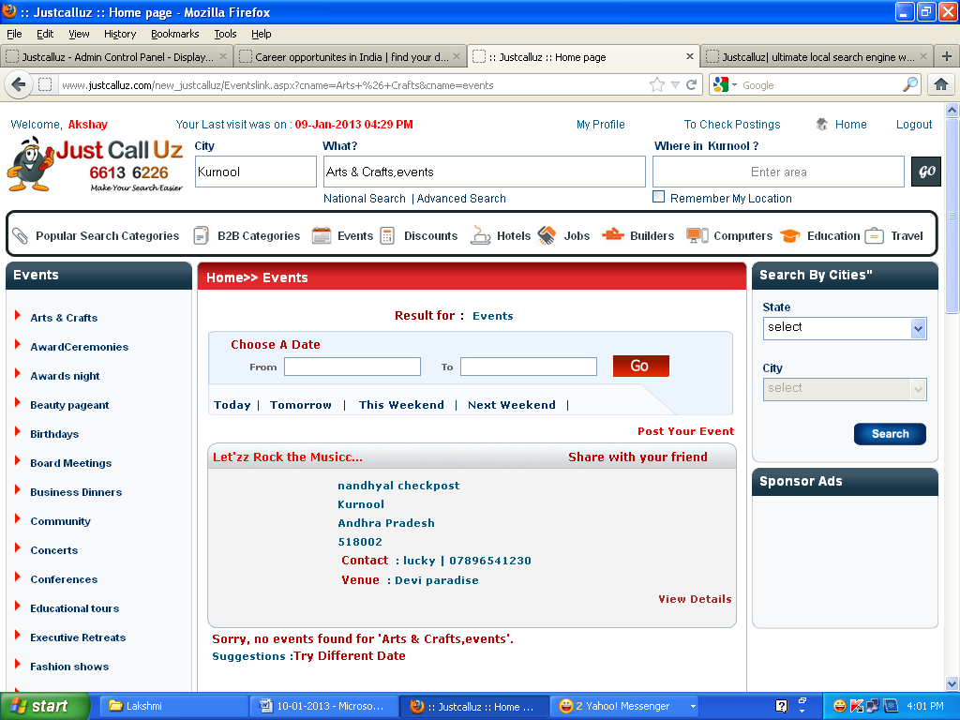

Got this message eventhough Selecting **Choose A Date**

Share with your friend option is not working